1) Introduction
- This assignment consists of a simple Cisco Packet Tracer home network diagram that includes:
- Router1 (R1)
- Switch0 (S1)
- Server0 (Web Server)
- Laptop0 (End Device 1)
- PC0 (End Device 2)
The connections between these devices are made using straight-through cables with the exception for the connection between the router and the server which uses cross-over cables.
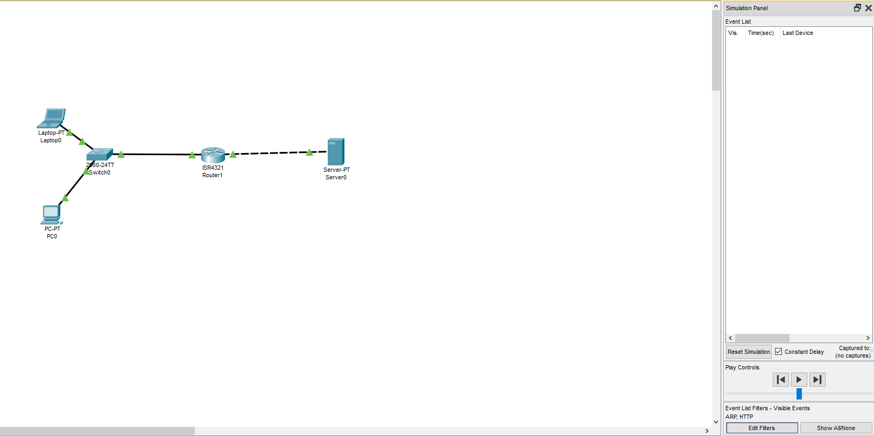
(Network design)
2) Process of Configuring the Home HTTP Web Server
IP addresses and subnet mask for the following devices:
Devices | IP Address | Subnet mask | Default Gateway
Router | Gigabit Ethernet 0/0/0: 10.1.1.35  Gigabit Ethernet 0/0/1: 10.1.2.46 | 255.255.255.0 | N/A
Switch | N/A | N/A | 10.1.1.35
Server | 10.1.2.100 | 255.255.255.0 | 10.1.2.46
Laptop | 10.1.1.13 | 255.255.255.0 | 10.1.1.35
PC | 10.1.1.24 | 255.255.255.0 | 10.1.1.35

Process Of:
Address Resolution Protocol (ARP):
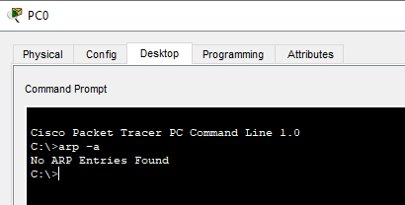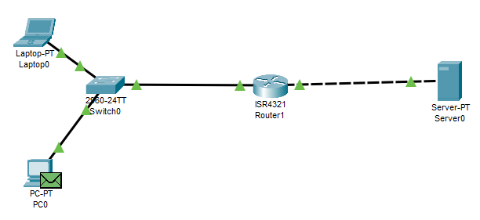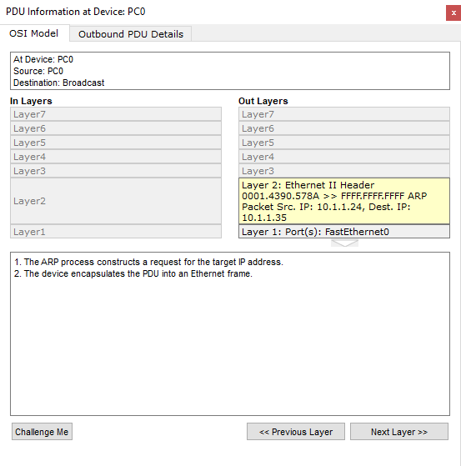
(ARP table at PC0) (ARP Frame at PC0) (PDU info at PC0)
From PC0 to switch0:
When PC0 wants to access the website on the server, it needs to send a HTTP request to the server, as the destination IP address is not in the LAN, thus the media access control(MAC) address is set to the default gateway. As PC0 does not have the MAC address of the router in its ARP table, it does an ARP broadcast which happens in the network access layer by doing the following:
PC 0 executes the ARP process, formulating an ARP request for the MAC address associated with the router's IP address.
PC0 creates a packet data unit (PDU) that includes information about the sender's MAC and IP addresses, as well as the target IP address with the Broadcast address FF-FF-FF-FF-FF-FF. The PDU is encapsulated into an Ethernet frame and transmitted Switch0.
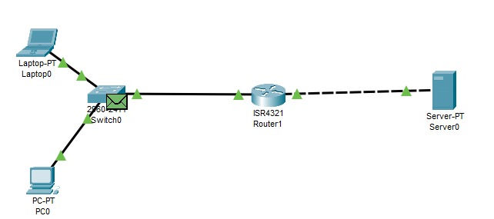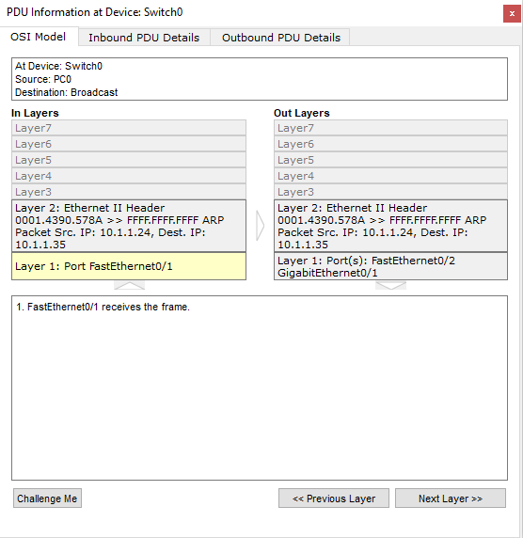
(ARP frame at Switch0) (PDU info at Switch0)
Switch0 receives the Frame and examines the frame’s Source and destination MAC address. It adds the frame source MAC address to its MAC table and verifies the frame's destination MAC address before it de-encapsulates the PDU from the ethernet frame. The switch then sends out the broadcast frame to all ports in the same LAN except the receiving port.

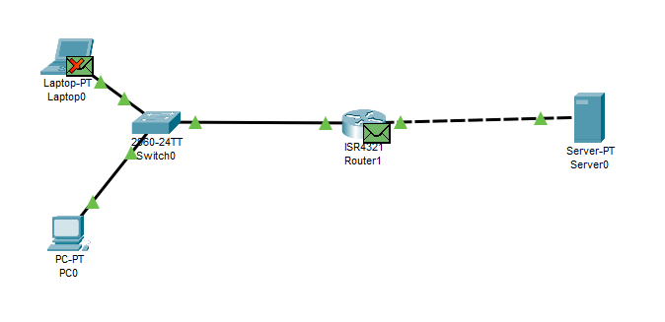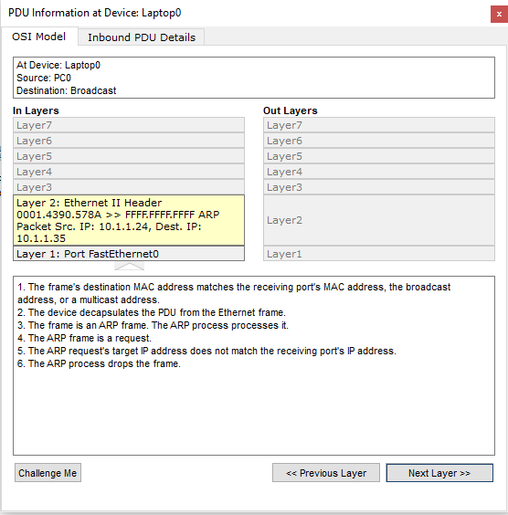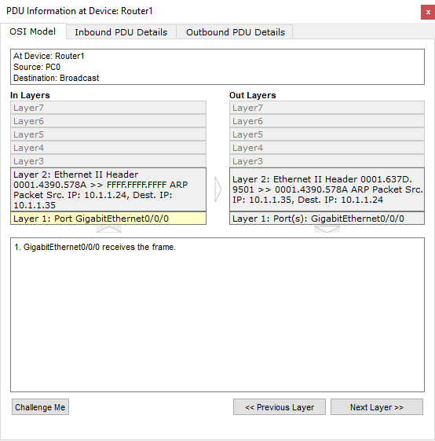
(switch sends out frame to all devices in LAN) (PDU info at laptop0) (PDU info at Router1)
Switch0 to Laptop0:
Laptop0 receives the frame from the switch, verifies the frame's destination MAC address and de-encapsulates the PDU from the Ethernet frame. However, realizing that the ARP request's target IP address does not match its own IP address, Laptop0 proceeds to drop the frame.
Switch0 to Router1:
Router1 receives the frame, it verifies the frame's destination MAC address and de-encapsulates the PDU from the Ethernet frame, the router's ARP process recognizes that the ARP request's target IP address aligns with its receiving port's IP address. Consequently, the ARP process updates the ARP table and replies to the ARP request. The reply is encapsulated into an Ethernet frame with the source MAC and IP addresses set to the router's MAC and IP address, the destination MAC and IP address as PC0's MAC and IP address. This frame is sent to the switch.
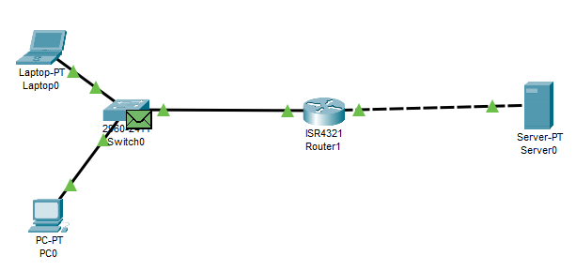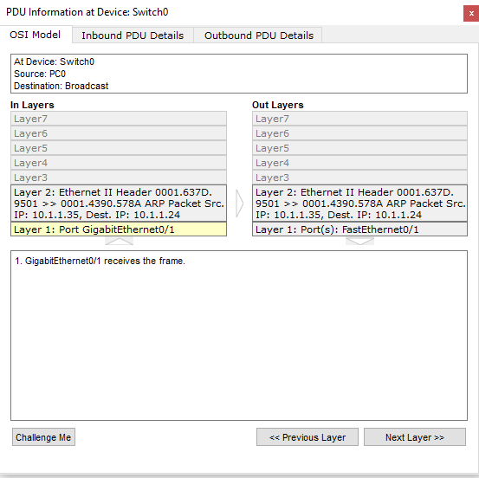
(ARP frame at Switch0) (PDU info at Switch0)
Router1 to switch0:
Switch0 receives the frame and looks in its MAC table for the destination MAC address based on the destination MAC address in the frame and sends the frame to PC0.

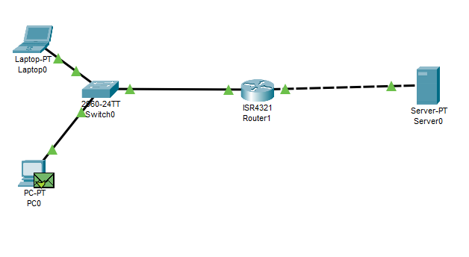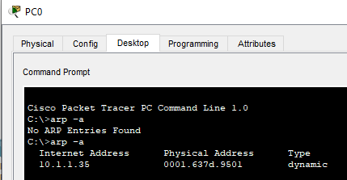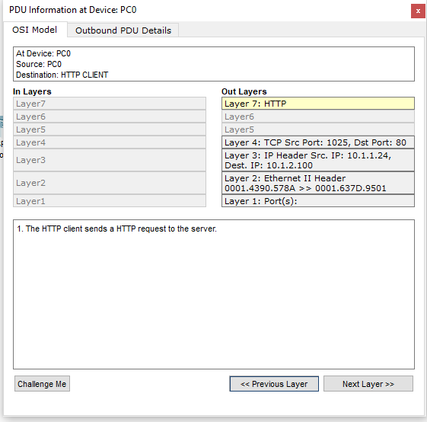
(ARP Frame at PC0) (ARP table at PC0) (PDU info at PC0)
Switch0 to PC0:
PC0 receives the frame, verifies the frame's destination MAC address and decapsulates the PDU from the Ethernet frame.
The ARP process then processes it and updates the ARP table with the received information.

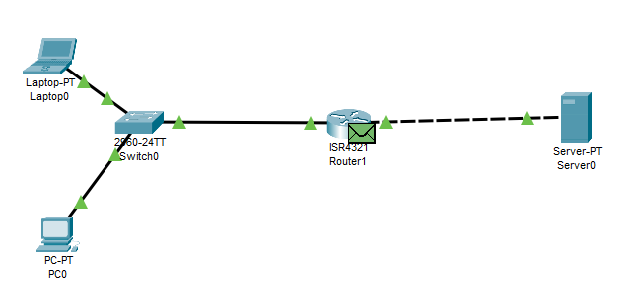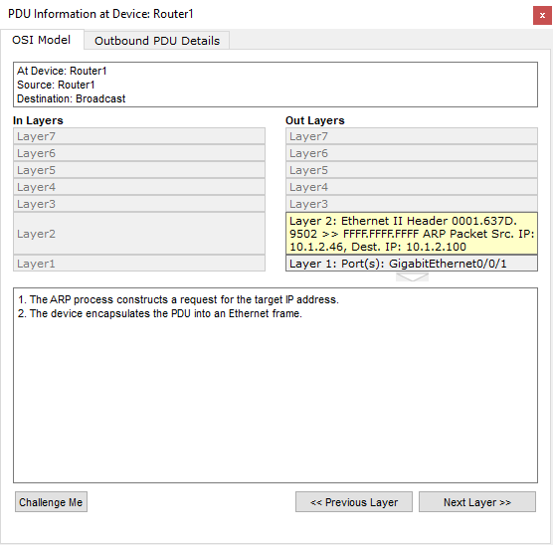
(ARP frame at Router 1) (PDU info at Router1) 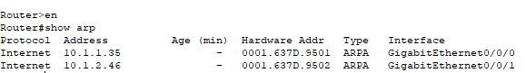
(ARP table of Router1)
Router1 to Server0:
Router 1 similarly does not have the MAC address of the server, thus it constructs an ARP request for the target IP address, creating a packet data unit (PDU) that includes information about the sender's MAC and IP addresses, as well as the target IP address with the Broadcast address FF-FF-FF-FF-FF-FF, which is encapsulated into an Ethernet frame. The router sends out the frame.
Server0 receives the ethernet frame, verifies the frame's destination MAC address and decapsulates the PDU from the frame. The ARP process processes the PDU, confirming that the ARP request's target IP address matches the receiving port's IP address. The ARP table is updated with the received information.

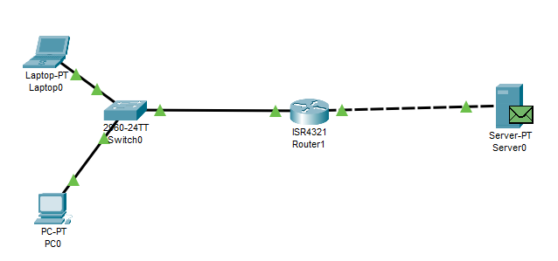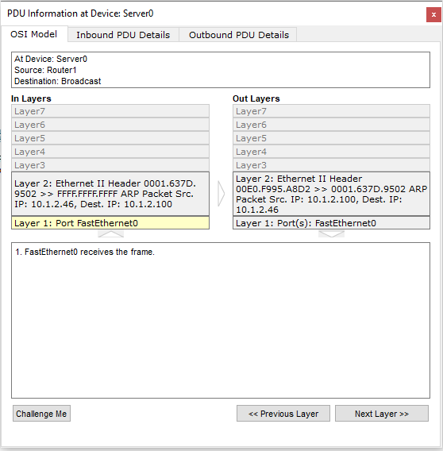
(ARP frame at Server0) (PDU info at Server0)
Server0 to Router1:
The ARP process replies to the request by encapsulating the PDU into an Ethernet frame with the source MAC and IP address is set to the server's MAC and IP address, the destination MAC and IP address as Router1's MAC and IP address and sent to Router1.

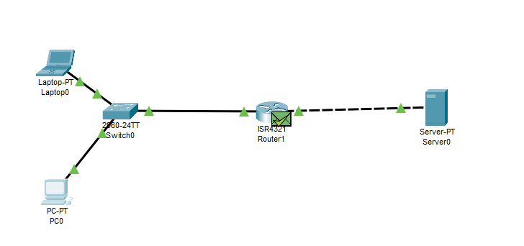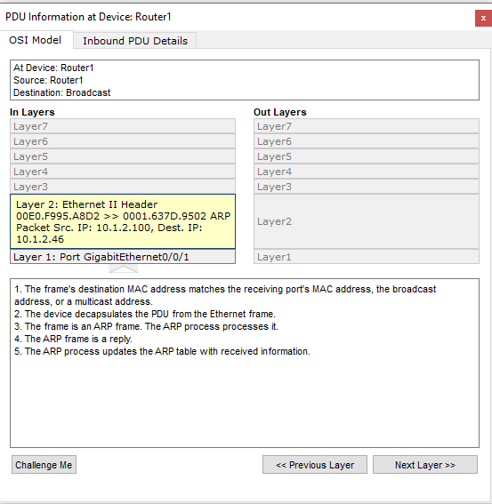
(ARP frame at Router1) (PDU info at Router1)
Router1 receives the frame, verifies the frame's destination MAC address and decapsulates the PDU from the Ethernet frame.
The ARP process processes it and confirms that the ARP request's target IP address matches the receiving port's IP address and updates the ARP table with received information.
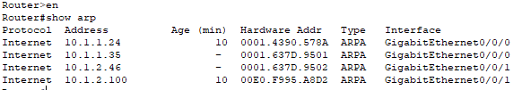
(ARP table of Router1)
HTTP:
PC0 to switch:
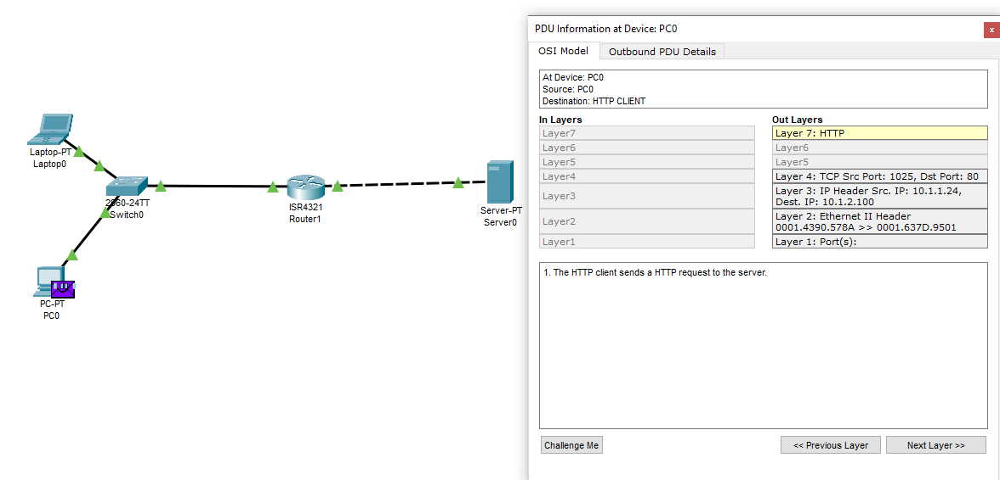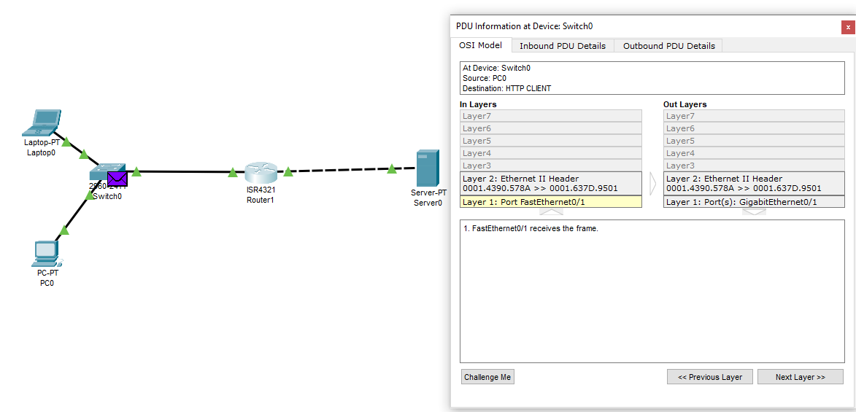
(HTTP frame at PC0) (PDU info at PC0) (HTTP frame at Switch0) (PDU info at Switch0)
PC0 sends an HTTP request at the application layer which is then encoded with transport layer information into a segment. It is further encapsulated with source IP and destination IP address of the default gateway as Server0 is not in PC0’s LAN.
The ARP process looks up its ARP table for the destination IP address and sets the destination MAC address found in the table.
PC0 encapsulates the PDU into an Ethernet frame and sends it out to the switch.

Switch0 to Router1:
Switch0 receives the frame and confirms that the frame source MAC address is found in the MAC table of the switch and looks through it for the destination MAC address.
It sends out the frame to Router1.
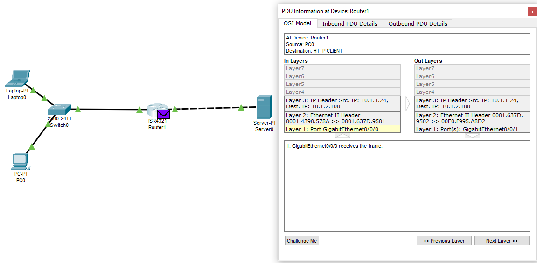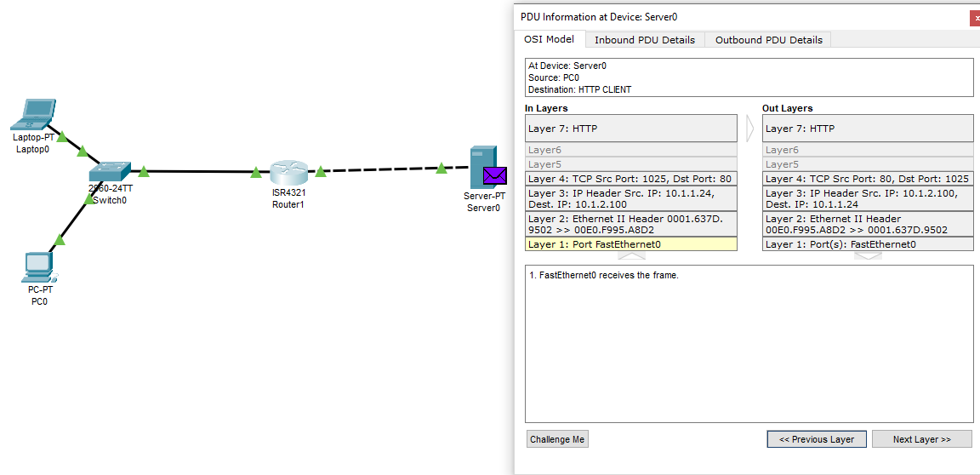
(HTTP frame at Router1) (PDU info at Router1) (HTTP frame at Server0) (PDU info at Server0)
Router1 to Server0:
Router1 receives the ethernet frame, verifies the frame's destination MAC address and decapsulates the PDU from the frame. Router1 looks for the destination IP address in the routing table and finding a routing entry, the ARP process checks its ARP table for the destination IP address and set the MAC address found in the table before encapsulating the PDU into an Ethernet frame and sends it to Server0.
Server0 receives the Ethernet frame, verifies the frame's destination MAC and de-encapsulates the PDU from the frame. The packet’s destination IP address matches Server0’s IP address thus Server0 de-encapsulates the packet and receives the TCP segment with the transport layer information. The segment has the expected information and thus the TCP processes the payload data and reassembles all data segments before passing them to the application layer, the device receives the HTTP request.
Server0 to Router1:
It responds with an HTTP reply, encapsulating the reply with transport layer information into a segment. It is further encapsulated into a packet with the IP address of the source IP address and destination IP address as the default gateway since the destination IP address is not in the LAN. Looking through the ARP table, it sets the MAC destination address. The packet is encapsulated into a frame and sent to the router.

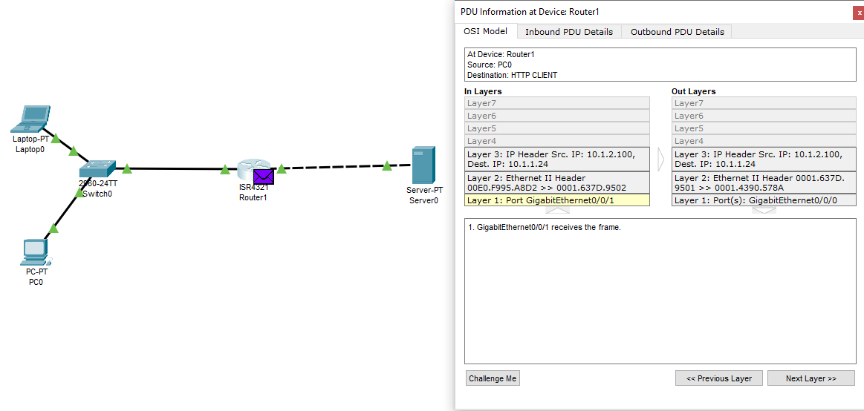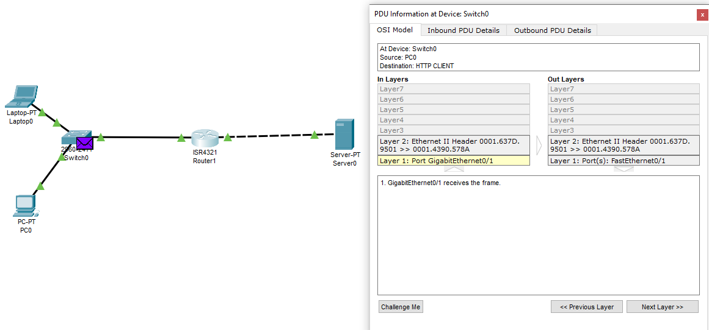
(HTTP frame at Router1)(PDU info at Router1) (HTTP frame at Switch0)(PDU info at Switch0)

Router1 to Switch0:
The router receives the frame, verifies the frame's destination MAC address and decapsulates the PDU from the Ethernet frame, looks up the destination IP address in the routing table.
The destination IP address is found, it then re-encapsulates the packet with a new ethernet frame and sends it to switch0.

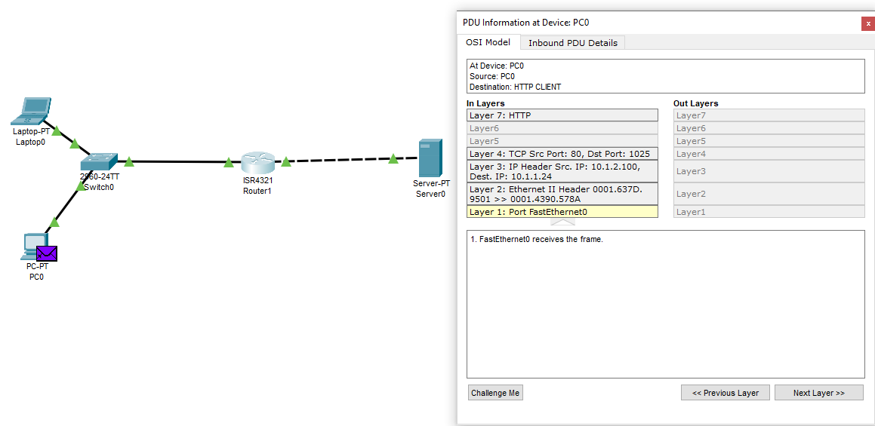
(HTTP frame at PC0) (PDU info at PC0)
Switch0 to PC0:
The switch receives the frame and finds the MAC sources address in the MAC table and looks at it for the destination MAC address. It then sends the frame to PC0.

PC0 receives the ethernet frame, verifies the frame's destination MAC address and decapsulates the PDU from the frame into a packet, The packet's destination IP address matches the device's IP address or the broadcast address, thus PC0 further de-encapsulates the packet and receives the transport layer information in the TCP segment.
The segment has the expected information and thus the TCP processes payload data and reassembles all data segments and passes to the application layer.
Finally, the HTTP client receives an HTTP reply from the server and displays the page in the web browser.
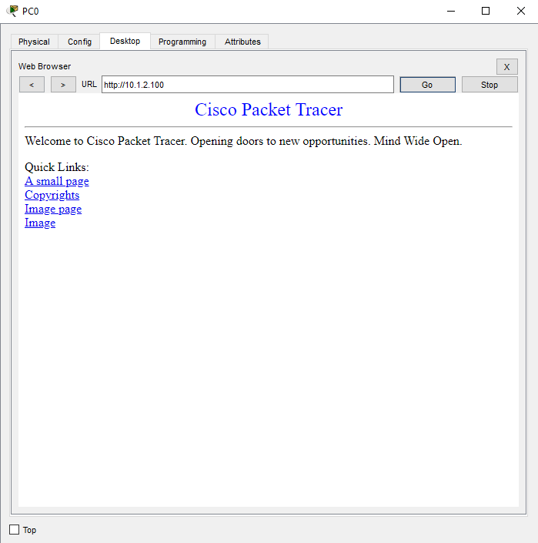
Conclusion:
Benefits of TCP/IP model:
Standardization:
Description: The TCP/IP model ensures interoperability by providing a common set of protocols, facilitating seamless communication between devices from different vendors.
Example: The network devices in the Packet Tracer are able communicate seamlessly using standardized TCP/IP protocols.
Ease of Implementation:
Description: The modular structure of the TCP/IP model simplifies the implementation of specific functionalities, making it straightforward to set up and configure devices.
Example: Configuring intermediary and end devices in the Packet Tracer is simplified, easy and similar due to the clear layer-wise organization.
Support for Diverse Applications:
Description: The TCP/IP model supports a wide range of applications, highlighting its versatility in accommodating diverse application requirements.
Example: The HTTP application for web browsing between devices (PC0 and Server0) and discovering the MAC destination address using ARP protocol is supported seamlessly in the network.
Modularity: It breaks down network communication into layers, making it easier to understand and troubleshoot.
Example: When troubleshooting in the packet tracer after encountering a problem, I can pinpoint the problem quickly and where it is occurring because of the TCP/IP model.
Efficient: It allows data to be transmitted in the fastest way possible.
Example: When the frames are travelling through the intermediary devices from PC0 to server0, its does not need to de-encapsulated fully, allowing us to program the device to de-encapsulate down to the necessary layer to extract the information needed for by the device, thus allowing the end device to see the webpage in the server in the fastest and most efficient way possible.

